
City news project
Project Document


Royal university of phnom penh
Phnom Penh, Cambodia
Project Scope
Project Title: City News Web Project
Date: 18 / 03 / 2023 Prepared By : Phong Chhengkim
Project Justification:
This project is basically updating the daily news into the website, so that the users can read every news that we update.
Product Characteristics and Requirements:
1. Secured database.
2. Only Admin that can register new account for user
5. Checking the Top view news.
Project Management Deliverables:
Project plan, Research finding report, Work breakdown structure, Scope statement, Project charter, Training manuals, lessons learned report etc.,
Project Success Criteria: Our main goal is to complete this project within allotted dead line.

1. Statement of Work

1. Scope of Work
The City News Web Project should manage different types of news such as National News (Politic, Social, Security), Sport News, Technology News, and any other resources which the management feels in the future could form a resource. A resource can be categorized to facilitate searching, sorting and managing the resources. This can be exemplified by dividing the news as being in politic or social. Client and Admin can easily to read and find the news categorized. The Client also easy to find the latest news and the most popular news. Client also can find the news that upload by their favorite news writer.

2. Location of Work
This Project is an Assignment for Web Development
3. Period of Performance
The duration of the project is 3 months. All the tasks are equally distributed among team members to accomplish the goal of completing the project.

4. Deliverables Schedule
Deliverable | Date Due
Learning on UI/UX and Project Work flow | Week 1 – Week 2
Design Project UI/UX | Week 3 – Week 5
Testing UI/UX work flow | Week 6
Learning on Dashboard and Design UI/UX and Project Work flow | Week 7 – Week 8
Working on Back-end using PHP and MySQL | Week 9 – Week 11
Testing whole Project and Prepare document for presentation | Week 12
5. Applicable Standards:
The project “City News” follows various programming standards.

6. Acceptance Criteria:
The acceptance criteria for the users are
- The website has to communicate with the database.
- Users can easily find the news with in less time
- Role are set for the account of the user.
7. Additional Requirements:
- A sound knowledge in programming languages such as PHP, and a knowledge of databases such as MySQL server.

Software Design Document

1. Introduction

Software Design Document is the design work product that formally documents the design of the software components. Software Design Document gives us the detailed description about the flow of the project.

1.1 Scope

The City News Web Project is being developed for the people who like to read news, but they are no have time to buy the magazine. The important modules that are going to implement in the proposed system.

- User easy to find the news that wrote by their favorite author
- Staff can add and modify the news
- Administrator can modify the staff role
- Administrator has all the privileges to add, modify and delete the news
- Only Administrator that can register new account for staff.

2. System Overview

The City News is a web-based application which is able to manage different types of News resources such such as National News (Politic, Social, Security), Sport News, Technology News, and any other resources which the management feels in the future could form a resource

- Basically, there are four views for the convenience of the user. In the home page view the user can find the lasted of every news type in library, in News details view the user can know the details of news. Administrator view the staff can have all the rights to add, modify all function and for Administrator has all the privileges to add, modify and delete the news these are the main functions of the system.

Context Diagram summarizes all processing activity and also helps users to view highest level of system with system boundaries. The system overview can be shown in the form of context diagram.

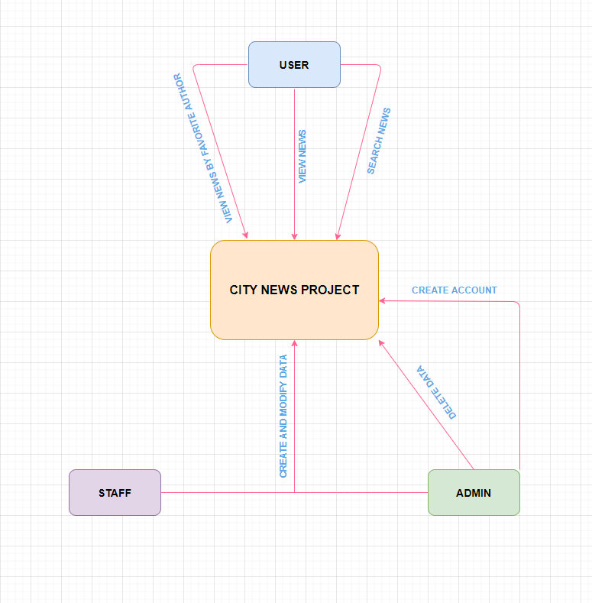

3. System Architecture
To develop software for Library management system the architecture that we are implementing is Three Tier Architecture. The User Interface Layer, Application Logic Layer and Data Storage Layer together called as Three Tier Architecture.

3.1 User Interface Layer

The User Interface Layer will consist of everything shown directly to the client. This Layer will communicate only with the Application Logic Layer. This Layer will also be responsible for initial validation of any admin inputted data. Any validation that requires communication to the Data Storage Layer will however be completed at the Logic Layer.

3.2 Data Storage Layer

The Data Storage Layer will record all information required by the Logic and User Interface Layer. This data will include Subject details for the Streams, and general user and admin user information. All passwords stored in the database will be encrypted to prevent unauthorized access. Within the Data Storage Layer a collection of SQL Queries will provide access to the data in a meaningful way.

4.0Database Description

The Database for City News Project consists of 11 tables. They are:

tbl_admin : id, name, email, password, profile
tbl_ads : id, ads, banner, ads small
tbl_contact : id, phone_number, address, email
tbl_logo : id, logo
tbl_news : id, banner, title, description, news_type, news_img, writer_profile, date, view
tbl_politic_banner : id, banner
tbl_security_banner : id, banner
tbl_social_banner : id, banner
tbl_social_link : id, icon, link
tbl_sport_banner : id, banner
tbl_techonology_banner : id, banner

Software Requirements Specification
1. Introduction

1.1. Purpose

The main objective of this document is to illustrate the requirements of the City News Project. The document gives the detailed description of the both functional and nonfunctional requirements proposed by the client. The document is developed after a number of consultations with the client and considering the complete requirement specifications of the given Project. The final product of the team will be meeting the requirements of this document.

1.2. Document Conventions

The following are the list of conventions and acronyms used in this document and the project as well:
- Administrator: A login id representing a user with user administration privileges to the software
- User: A general login id assigned to most users
- Client: Intended users for the software
- SQL: Structured Query Language; used to retrieve information from a database
- SQL Server: A server used to store data in an organized format
- Layer: Represents a section of the project
- User Interface Layer: The section of the assignment referring to what the user interacts with directly.
- Data Storage Layer: The section of the assignment referring to where all data is recorded
- Data flow diagram:It shows the dataflow between the entities.
- Interface: Something used to communicate across different mediums
- Unique Key: Used to differentiate entries in a database

3. System Features

3.1. Database – Storage

3.1.1. Description and Priority

Proposed Database is intended to retrieve, update, and manipulate information related to project which include

- News Details
- Logo Details
- Admin Details
- News type Details

3.1.2. Stimulus / Response Sequences

Responses for Administrator: The administrator can Login and Logout. When the Administrator Logs into the City News Project. The system will check for validity of login .If the Login and password are valid, the response to this action is the administrator will be able to modify, view, add, deleting and all other functions that can be performed on the database.

3.2. Functional Requirements

This section gives the list of Functional and non functional requirements which are applicable to the City News Project.

3.2.1 Interface Requirements

This section describes how the software interfaces with other software products or users for input or output.

3.2.1.1UserInterfaces
Describes how this product interfaces with the user.

GUI - Describes the graphical user interface if present. This section should include a set of screen dumps or mockups to illustrate user interface features.

Description - The user interface must be customizable by the administrator

Criticality- This issue is essential to the overall system. All the modules provided with the software must fit into this graphical user interface and accomplish to the standard defined.
Technical issues - In order to satisfy this requirement the design should be simple and all the different interfaces should follow a standard template. There will be the possibility of changing colors and images, plus switching between interfaces with the minimum impact for the users.

Risks - To reduce the circumstances under which this requirement might not able to be satisfied, all the designers must have been developed web sites previously and they must be aware of html restriction and cross browsers implementations before starting the designing. In order to reduce the probability of this occurrence the entire design team will be trained in basic html development and macromedia fireworks, this tool will be used instead of Photoshop.

Dependencies with other requirements - All user interfaces should be able to interact with the user management module and a part of the interface must be dedicated to the login/logout module

4. Non Functional Requirements

4.1. Hardware Interfaces
Server Side:
- Operating System: Windows 9x/xp ,Windows ME
- Processor: Pentium 3.0 GHz or higher
- RAM: 256 Mb or more
- Hard Drive: 10 GB or more
Client side:
- Operating System: Windows 9x or above, MAC or UNIX.
- Processor: Pentium III or 2.0 GHz or higher.
- RAM: 256 Mb or more

4.2. Software Interfaces
- Database: MySQL Server.
- Application: PHP

5. Other Nonfunctional Requirements

5.1 Design Constraints
The system must be designed to allow web usability. That is, the system must
be designed in such a way that will be easy to use and visible on most of the browsers.

